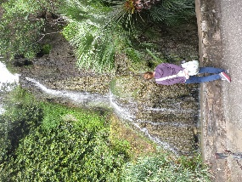Hey, this is Lesley. I am a Montessori guide navigating the public sector in Austin. I love spending time with my husband and our two cats. I enjoy collaborating, and I also hope to hear your thoughts along the way.